Processor Audio SDK Setup Guide****

Rev. 0.70

29 September 2017

|  |  |  |  |
| --- | --- | --- | --- |
| **Revision History** | | | |
| **Version** | **Date** | **Description of changes** | **Author(s)** |
| 0.10 | 23-Aug-16 | Initial version | Frank Livingston |
| 0.20 | 30-Aug-16 | Added gmake clean to UART LLD build instructions | Frank Livingston |
| 0.30 | 08-Dec-16 | Updated for AR2 | Frank Livingston |
| 0.40 | 17-Mar-17 | Updated for AR4 | Frank Livingston |
| 0.50 | 14-Jun-17 | Updated for BR1 | Frank Livingston |
| 0.60 | 08-Sep-17 | Updated for BR3 | Frank Livingston |
| 0.70 | 29-Sep-17 | Updated for 1.0.0.6 | Frank Livingston |

**Table of Contents**

1 Introduction 5

2 Required Hardware 5

3 Software Installation 6

3.1 Code Composer Studio (CCS) 6

3.2 Processor SDK-RTOS 6

3.3 Open Source Package 6

3.4 Firmware Deliverable Package 7

3.5 Dolby IP Packages 7

3.6 DTS IP Packages 8

3.7 CCS Update 8

3.8 PASDK OS Dev Build and Alpha Communication Tools 9

4 Emulator Firmware Update 9

5 Software Build 10

5.1 PASDK OS Dev Libraries 10

5.2 DSP Application 10

5.3 ARM Application 12

6 Application Execution and Test 13

6.1 I/O Configuration 13

6.2 Connect EVM 14

6.2.1 ADC 8-Ch Input and DAC 8-Ch Output 15

6.2.2 S/PDIF Input and DAC 8-Ch Output 15

6.2.3 HDMI Input and DAC Output 15

6.3 Load and Execute Code 15

6.4 PyAlpha Python Scripts for Alpha Communication 16

6.5 Alpha Commands for AE0 Configuration/Status 17

7 APPENDIX A: DTSX Test Setup and Integration 18

7.1 Test Setup 18

7.2 Integration 21

7.2.1 DTSX Decoder Integration on K2G ARM Core 21

7.2.2 PARMA Integration on K2G C6x Core 22

# Introduction

This document provides installation and setup instructions for Release 1.0.0.6 (R1.0.0.6) of Processor Audio SDK (PASDK) 1.0 for K2G provided by Texas Instruments, Inc. (TI). R1.0.0.6 incorporates several packages: (1) the Open Source (OS) package; (2) the Firmware Deliverable (FD) package; (3) the Dolby Atmos IP package; and (4) the DTS DTSX IP package. The R1.0.0.6 features provided by these packages are detailed below.

1. OS package
   * Audio input drivers: HDMI input, and 8-channel ADC or S/PDIF (optical only) input.
   * Audio output drivers: up to 16-channel DAC output.
   * Control I/O drivers: UART, SPI and I2C.
   * PCM decoder.
   * PCM encoder with DEL and VOL ASP phases.
   * DEL3, DM, FIL, SRC, ML0 and AE0 ASP’s.
   * Framework supporting I-topology, with decoders executing on ARM and ASP’s executing on DSP.
2. FD package
   * SNG decoder.
   * BM2, DEM and GEQ3 ASP’s.
3. Dolby Atmos IP packages
   * Dolby Intrinsics 1.8.1.1.
   * Dolby Digital Plus (DDP) decoder 4.7.2.
   * Metadata-enhanced Audio Transmission (MAT) decoder 2.1.2.
   * TrueHD (THD) decoder 3.3.3.
   * Channel Audio Renderer (CAR) 1.0.0.
   * Object Audio Renderer (OAR) 1.0.0 & Object Audio Renderer Interface (OARI) 1.1.11 from SIDK 1.3.
   * Bass Management (BMDA) from SIDK 1.3.
4. DTS DTSX IP packages
   * DTSX/PARMA 3.90.50.1.

# Required Hardware

The hardware listed below is required for complete R1.0.0.6 functionality:

1. Mistral K2G Rev. D EVM (SPRW274).
2. Mistral K2G EVM Audio Daughter Card Rev. B (SPRW279).
3. Momentum Data Systems (MDS) HDMI repeater kit, including:
   * MDS HSR41P HDMI Repeater module Rev. A.
   * MDS DA10X Interface board (IFB) Rev. A.
   * 5V AC to USB power supply for IFB and HSR41P.
   * Short 26- and 34-wire ribbon cables for connecting HSR41P and IFB.
   * Long 34-wire ribbon cable for connecting IFB and Audio Daughter Card.
4. MPC-HC player.

* It is used to stream DTS streams to K2G EVM via HDMI from Windows PC.
* The MPC-HC installer can be downloaded at: <https://mpc-hc.org/downloads/>
* The detailed test setup and integration information can be found in APPENDIX A.

# Software Installation

## Code Composer Studio (CCS)

R1.0.0.6 was developed using CCS versions 6.1.2.00015 and 7.1.0.00016 on Windows. Download the Off-line Installers for these versions of CCS at the following URLs:

<http://processors.wiki.ti.com/index.php/Download_CCS#Code_Composer_Studio_Version_6_Downloads>

<http://processors.wiki.ti.com/index.php/Download_CCS#Code_Composer_Studio_Version_7_Downloads>

Install CCS 6.1.2 to C:\ti. During CCS installation:

* For “Processor Support”, select “Multi Core Processors (all)”
* For “Select Debug Probes”, select “TI XDS Debug Probe Support” and “Spectrum Digital Debug Probes and Boards”

Install CCS 7.1.0 to C:\ti. During CCS installation:

* For "Processor Support", select "66AK2x multicore DSP + ARM Processors & C66x Keystone multicore DSP"
* For "Select Debug Probes", select "Spectrum Digital Probes and Boards"

R1.0.0.6 was developed using the code generation tools listed below.

* GNU ARM Tools 4.8.0.2014q3-20140805 (installed as part of CCS 6.1.2).
* C6000 v8 Compiler Tools: 8.1.0 (installed as part of CCS 6.1.2).
* C6000 v7 Compiler Tools: 7.4.4. (Only used to build DTSX Parma libraries. The Installer can be downloaded at <http://software-dl.ti.com/codegen/non-esd/downloads/download.htm>).

## Processor SDK-RTOS

R1.0.0.6 was developed using Processor SDK-RTOS 4.0.0.4 for K2G on Windows. Release information for this version of Processor SDK-RTOS is provided at the URL below, along with a link to the installer:

<http://software-dl.ti.com/processor-sdk-rtos/esd/K2G/04_00_00_04/index_FDS.html>

Install all components of Processor SDK-RTOS to C:\ti. Among others, this will install the tools in the following list:

* SYS/BIOS 6.46.05.55
* XDAIS 7.24.00.04
* XDC Tools 3.32.01.22

## Open Source Package

The R1.0.0.6 OS package is distributed using a self-extracting executable. Follow the steps below to install the software.

1. Double click the executable to initiate the installation process. Continue to the License Agreement.
2. Accept the terms of the click-wrap license agreement.
3. Change the installation destination folder if desired, or accept the default c:\ti\processor_ sdk_audio_1_00_00_06 in the Choose Destination Location window. Complete the installation.

Upon completion of the installation, the installation root folder (<pasdk_root>) contains the sub-folders described in the table below.

|  |  |
| --- | --- |
| **Folder** | **Contents** |
| docs\ | User documentation |
| pasdk\ | PASDK OS Dev (paf\)  ARM application (common\, shared\, test_arm\  DSP application (common\, shared\, test_dsp\) |
| psdk_cust\ | Library Architecture and Framework (libarch_k2g_1_0_1_0\) |
| scripts\ | Build scripts |
| tools\ | Alpha communication tools |

## Firmware Deliverable Package

The R1.0.0.6 FD package is distributed as a .zip archive. To install the software, unzip the package .zip file to <pasdk_root>\pasdk\paf. The FD package root folder is “pa”, so unzipping the file should overwrite the pa folder in paf and overwrite or create the sub-folders described in the table below.

|  |  |
| --- | --- |
| **Folder** | **Contents** |
| pa\asp | ASP IP (bm2, dem, geq3) header files |
| pa\build | Decoder and ASP IP libraries for ARM (sng1) and DSP (bm2, dem, geq3) |
| pa\dec | Decoder IP (sng1) header files |
| pa\docs | User documentation |

## Dolby IP Packages

The R1.0.0.6 Dolby IP packages are distributed using a select-extracting executable. Follow the steps below to install the software.

1. Double click the executable to initiate the installation process. Continue to the License Agreement.
2. Accept the terms of the click-wrap license agreement.
3. Accept the default installation folder, or change the folder to the desired location of the Dolby IP packages (e.g. <pasdk_root>\release\dhip_package). Complete the installation.
4. Upon completion of the installation, unzip all Dolby IP .zip packages (bmda, car, oar, ddp, intrinsics, matthd, and oar) to <pasdk_root>\dolby_ip\dh-ip. After unzipping the Dolby IP .zip packages, the dh-ip folder should contain the sub-folders described in the table below.

|  |  |
| --- | --- |
| **Folder** | **Contents** |
| asp\ | ASP IP (bmda, car, oar) header files |
| build\ | IP libraries for ARM (ddp, mat, thd) and DSP (bmda, car, instrinsics, oar) |
| dec\ | Decoder IP (ddp, mat-thd) header files |
| DOC\ | User documentation |

## DTS IP Packages

The R1.0.0.6 DTS IP packages are distributed using a select-extracting executable. Follow the steps below to install the software.

1. Double click the executable to initiate the installation process. Continue to the License Agreement.
2. Accept the terms of the click-wrap license agreement.
3. Accept the default installation folder, or change the folder to the desired location of the DTS IP packages (e.g. <pasdk_root>\release\dtsip_package). Complete the installation.
4. Upon completion of the installation, the unzip dtsx and parma .zip packages to <pasdk_root>\3p-ip-dts\dtsx-ip. After unzipping .zip packages, the dtsx-ip folder should contain the sub-folders described in the table below.

|  |  |
| --- | --- |
| **Folder** | **Contents** |
| asp\ | ASP IP (parma) header files |
| build\ | IP libraries for ARM (dtsx) and DSP (parma) |
| dec\ | Decoder IP (dtsx) header files |
| DOC\ | User documentation |

## CCS Update

Update the CCS 7.1.0 installation as below:

1. Launch CCS and create a new workspace (e.g. <pasdk_root>\pasdk\workspace_pasdk).
2. Allow installation of newly discovered products located in c:\ti.
   * Ignore any messages about unsigned content
   * Restart CCS when prompted
3. Update Tools discovery path to access C6000 CGT 8.1.0 and ARM Tools 4.8.0.2014q3-20140805.
   * Select Window→Preferences
   * Select Code Composer Studio→Build→Compilers
   * Click Add next to Product Discovery Path, add folder c:/ti/ccsv6/tools/compiler

## PASDK OS Dev Build and Alpha Communication Tools

Download and install the additional tools below. Sed and Python are required to build the PASDK OS DEV software contained in the <pasdk_root>\pasdk\paf folder. Python is also required for alpha command control I/O over using the PyAlpha tool. The PyAlpha tool is further described below in Section 6.4.

1. Obtain Sed 4.2.1 from <http://gnuwin32.sourceforge.net/packages/sed.htm>,

executable installer, sed-4.2.1-setup.exe.

Install to c:\PA_Tools\GnuWin32 (or change installation location in <pasdk_root>\pasdk\setup_env.bat).

1. Obtain Python 2.7.6 from <https://www.python.org/download/releases/2.7.6>

executable installer, python-2.7.6.amd64.msi.

Install to c:\PA_Tools\Python27 (or change installation location in <pasdk_root>\pasdk\setup_env.bat).

1. Once Python is installed, run **<pasdk_root>\scripts\setup_env.bat** and then navigate to **<pasdk_root>\tools\** and run **setup.bat** to install PyAlpha dependencies.

# Emulator Firmware Update

The K2G EVM on-board emulator firmware must be updated for correct emulator operation. Update the firmware as described below.

1. Connect the EVM to the host PC using the provided USB Mini B to A plug type cable. Connect the Mini B plug on the cable to XDS_USB connector J1 on the EVM.
2. Connect the EVM to power using the supplied 12V power supply.
3. Apply power to the EVM by pushing the SW1 switch to the “ON” position.
4. Open a DOS prompt on the PC. At the DOS prompt, issue these commands:  
   > cd c:\ti\ccsv6\ccs_base\common\uscif\xds2xx  
   > update_xds2xx.bat xds200
5. The batch file output should appear as shown below.  
   Updating CPLD ...  
   .  
   Updating Firmware ...  
   .  
   Rebooting ...  
   .  
   Reading Configuration ...  
   .  
   Check swRev is 1.0.0.8 or higher  
   .  
   boardRev=4  
   ipAddress=0.0.0.0  
   ipConfig=dhcp  
   ipGateway=0.0.0.0  
   ipNetmask=0.0.0.0  
   productClass=XDS2XX  
   productName=XDS200  
   serialNum=00:0E:99:03:90:0F  
   swRev=1.0.0.8  
   hostCPU=AM1802  
   emuCtrlType=Bit bang  
   extMemType=SDRAM  
   portUSB=true  
   portENET=false  
   portWIFI=false  
   portRS232=false  
   EnableUSBSerial=false  
   CurrentMeasure=false  
   Press any key to continue . . .

# Software Build

## PASDK OS Dev Libraries

The ARM and DSP applications depend on several libraries located in the <pasdk_root>\pasdk\paf folder. Detailed instructions for building any of the libraries in this folder are contained in <pasdk_root>\pasdk\paf\ReadMe.txt. However, batch files for building only the necessary libraries for the ARM/DSP applications are provided in the <pasdk_root>\scripts folder. To build the required libraries:

1. Open a DOS prompt.
2. From the DOS prompt in <pasdk_root>, execute:  
   > cd scripts  
   > setup_env.bat  
   > build_paf_libs.bat

## DSP Application

To build the DSP application:

1. Import the “test_dsp” CCS project into the CCS workspace. The project is located in <pasdk_rooot>\pasdk\test_dsp.
2. Select the desired build configuration
   * For Dolby Harmony: right-click test_dsp project in CCS Project Explorer, select Build Configurations→Set Active→Project→Debug_DH_IPPkgs.
   * For DTS:X: right-click test_dsp project in CCS Project Explorer, select Build Configurations→Set Active→Project→ Debug_DTSX_IPPkgs.
3. Ensure the correct component software versions are selected in the RTSC control panel (See Figure 1 below).
   * Right-click test_dsp project in CCS Project Explorer, select Properties.
   * On left-hand side of window, select General. Select RTSC tab on right-hand side of General window.
   * Confirm the following PrSDK 4.00.00.04 components are installed and selected:
     1. SYS/BIOS 6.46.5.55.
     2. System Analyzer (UIA Target) 2.0.6.52.
     3. XDAIS 7.24.0.04.
     4. DSPLIB C66x 3.4.0.0.
     5. IPC 3.46.00.02.
     6. EDMA3 LLD 2.12.4.
     7. k2g PDK 1.0.6.
   * Click OK.
4. Rebuild the project using the selected build profile.
   * Right-click test_dsp project in CCS Project Explorer, select Rebuild Project.

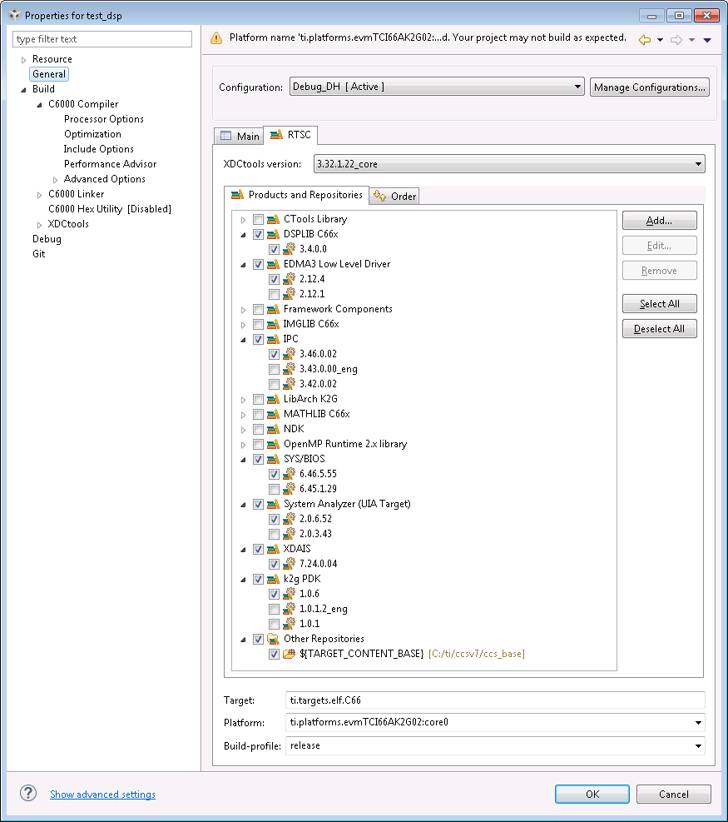

Figure 1: DSP Application RTSC Configuration

## ARM Application

To build the ARM application:

1. Import the “test_arm” CCS project into the CCS workspace. The project is located in <pasdk_root>\pasdk\test_arm.
2. Select the desired build configuration
   * For Dolby Harmony: right-click “test_arm” project in CCS Project Explorer, select Build Configurations→Set Active→Project→Debug_DH_IPPkgs.
   * For DTS:X: right-click “test_arm” project in CCS Project Explorer, select Build Configurations→Set Active→Project→Debug_DTSX_IPPkgs.
3. Ensure the correct component software versions are selected in the RTSC control panel (See Figure 2 below).
   * Right-click test_arm project in CCS Project Explorer, select Properties.
   * On left-hand side of window, select “General”. Select RTSC tab on right-hand side of General window.
   * Confirm the following PrSDK 2.00.02.11 components are installed and selected:
     1. SYS/BIOS 6.46.5.55.
     2. System Analyzer (UIA Target) 2.0.6.52.
     3. XDAIS 7.24.0.04.
     4. IPC 3.46.00.02
   * Click OK.
4. Rebuild the project using the selected build profile.
   * Right-click test_arm project in CCS Project Explorer, select Rebuild Project.

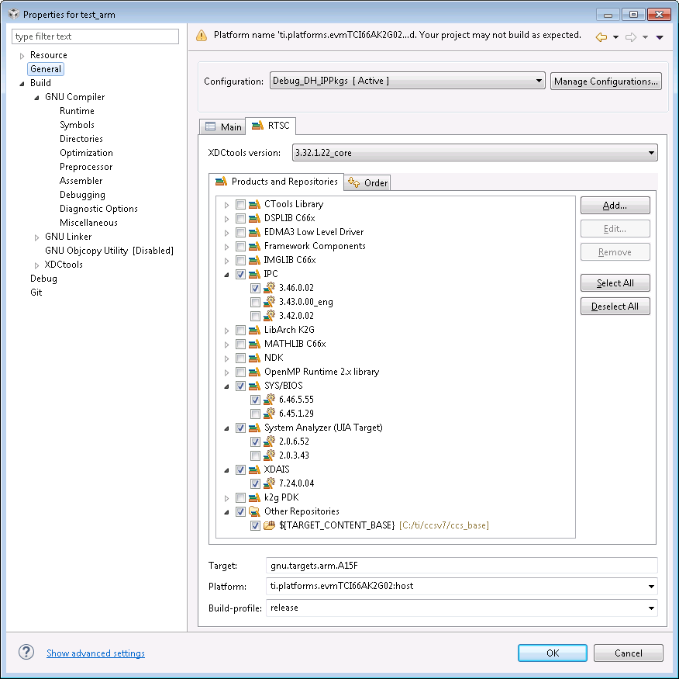

Figure 2: ARM Application RTSC Configuration

# Application Execution and Test

## I/O Configuration

R1.0.0.6 supports boot- and run-time I/O configuration. Boot-time I/O configuration is determined by the at-boot I/O shortcuts in the CUS_ATBOOT_S definition in <pasdk_root>\pasdk\test_dsp\application\itopo\evmk2g\atboot.c, while run-time I/O configuration is performed by invoking I/O shortcuts via alpha commands. The available Input and Output shortcuts are defined in <pasdk_root>\pasdk\test_dsp\application\itopo\evmk2g\io.c and described in the tables below.

|  |  |
| --- | --- |
| **Input Configuration** | **Input Shortcut** |
| ADC 8-ch (w/ DAC 8-ch input) | execPAIInAnalog |
| S/PDIF | execPAIInDigital |
| Stereo HDMI (PCM or DDP) | execPAIHDMIInStereo |
| HDMI  (MAT-THD/PCM) | execPAIInHDMI |

|  |  |
| --- | --- |
| **Output Configuration** | **Output Shortcut** |
| DAC 8-ch (w/ ADC 8-ch input) | execPAIOutAnalogSlave |
| DAC (8-ch) | execPAIOutAnalog |
| DAC (12-ch) | execPAIOutAnalog12Ch |
| DAC (16-ch) | execPAIOutAnalog16Ch |

## Connect EVM

1. Turn off power to the EVM using SW1 on the EVM. Disconnect the 12V power supply.
2. Assemble the Audio Daughter Card (assembly instructions are packaged with Audio Daughter Card).
3. Attach the Audio Daughter Card to the K2G EVM. The Audio Daughter Card connects to the EVM through the JP1 “Audio Expansion” and J12 “Serial Expansion” connectors on EVM.
4. Connect the PC and K2G EVM using DB9 serial RS-232 cable delivered with EVM.
   * A USB to UART FTDI cable can be used on the PC side of the connection.
   * Attach the DB9 connector to the P1 “UART0” connector on the EVM.
   * Push the SW12-UART0_DB9_EN switch to the “ON” position.
5. Connect the EVM emulation port to the PC as described in Section 4.
6. Connect the MDS HSR41P to the MDS IFB.
   * Connect HSR41P J4 “Main” header to the IFB J5 “Main” header using the short 26-wire ribbon cable. Ensure the red wire on the ribbon cable is connected between HSR41P J4 Pin1 and IFB J5 Pin1.
   * Connect HSR41P J7 “Sec” header to the IFB J2 “Sec” header using the short 34-wire ribbon cable. Ensure the red wire on the ribbon cable is connected between HSR41P J7 Pin1 and IFB J2 Pin1.
7. Connect the MDS IFB to the Audio Daughter Card. Connect IFB J3 “McASP0” header to Audio Daughter Card “I2S Header” using the supplied long 34-wire ribbon cable. Ensure the red wire on the ribbon cable is connected between IFB J3 Pin1 and Audio Daughter Card “I2S Header” Pin1 (note the “I2S Header” is only 32 pins, so the two wires on the ribbon cable opposite Pin1 are unused).
8. Connect HDMI cable from audio source (e.g. Blu-ray player) to HSR41P J6 “IN”. Connect HDMI cable to audio sink (e.g. HDMI enabled monitor) from HSR41P J8 “HDMI OUT”.
9. Connect 5V AC to USB power supply to IFB power connector J1.
10. Re-connect the 12V power supply to the EVM. Turn on power to the EVM using SW1.

### ADC 8-Ch Input and DAC 8-Ch Output

Connect ADC inputs to the ADC_IN0-3 input jacks on the Audio Daughter Card. Processed PCM samples will be output to the corresponding DAC output jacks DAC_OUT0-3 on the Daughter Card.

### S/PDIF Input and DAC 8-Ch Output

Connect S/PDIF input to the MOD1 Digital Input (Optical) connector on the Audio Daughter Card. Processed PCM samples will be output to the DAC output jacks DAC_OUT0-3 on the Daughter Card.

### HDMI Input and DAC Output

Connect HDMI input source to the HSR41P repeater module as described above. Processed PCM samples will be output to DAC output jacks DAC_OUT0-6 on the Daughter Card. The number of active DAC outputs depends on: (1) the selected Output Shortcut (execPAIOutAnalog, execPAIOutAnalog12Ch, or execPAIOutAnalog16Ch); (2) the configured ENC channel map from; and (3) the active renderer channel configuration request. For example, issue the alpha commands listed below to enable 12-channel DAC for channel-based audio using CAR with speaker layout L/R, C, Sub, Ls/Rs, Lrs/Rrs, Ltf/Rtf, Ltr/Rtr:

**CMD> python pyalpha execPAIOutAnalog12Ch**

alpha execPAIOutAnalog12Ch

**CMD> python pyalpha writeENCChannelMapFrom16(PAF_LEFT,PAF_RGHT,PAF_LSUR,PAF_RSUR,PAF_CNTR,PAF_SUBW,PAF_LBAK,PAF_RBAK,PAF_LTFT,PAF_RTFT,PAF_LTRR,PAF_RTRR,-3,-3,-3,-3)**

**CMD> python pyalpha writeSYSChannelConfigurationRequestSurround4LtfRtfLtrRtr_1**

alpha /* none */

**CMD> python pyalpha readCARChannelCfgOverride**

alpha writeCARChannelCfgOverrideUnknown

## Load and Execute Code

Follow the steps below from within CCS to load and execute the DSP and ARM application code:

1. Click View→Target Configurations.
2. In the Target Configurations window, open the Projects→test_dsp→targetConfigs folder.
3. Right-click on K2GEVM.ccxml contained in the targetConfigs folder.
4. Select Launch Selected Configuration.
5. In the Debug window, right-click on the C66x and select Connect Target. The output from the GEL code invoked on the target connection can be observed in the Console output window. The final line of this output should read “C66xx: GEL Output: DDR3A initialization complete”.
6. In the Debug window, right-click on the CortexA15 and select Connect Target. The output from the GEL code invoked on the target connection can be observed in the Console output window. The final line of this output should read “CortexA15: GEL Output: A15 non secure mode entered”.
7. In the Debug Window, click on the C66x and then open Run→Load→Load Program. In the Load Program window, click on Browse project, open the “test_dsp” folder, and click on “test_dsp.out” and OK to select the program to be loaded. Click on OK in the Load Program window to load the program to the C66x.
8. In the Debug Window, click on the CortexA15, and then open Run→Load→Load Program. In the Load Program window, click on Browse project, open the “test_arm” folder, and click on “test_arm.out” and OK to select the program to be loaded. Click on OK in the Load Program window to load the program to the A15.
9. In the Debug window, click on the C66x and then Open Run→Resume to execute the DSP code.
10. In the Debug window, click on the CortexA15 and then Open Run→Resume to execute the ARM code.
11. The CIO Console output window should display memory usage statistics. The final line of output should display the memory usage summary for the EXT NC SHM heap.

## PyAlpha Python Scripts for Alpha Communication

R1.0.0.6 supports alpha command control over UART using the PyAlpha tool located in <pasdk_root>\tools. PyAlpha is invoked on the command-line in a DOS shell. PyAlpha documentation can be obtained by executing PyAlpha with a “--help” argument as below (note: the Python executable is contained in the DOS shell path for this example).

**> T:**

**> cd tools  
> python pyalpha --help**

usage: PyAlpha [-?] [-h FILE] [-I DIR] [-p PORT] [-b BAUD] [-t DIR] [-bin DIR]

[-r] [-s] [--fast] [--repeat N T N T] [-log LEVEL]

[ALPHAS [ALPHAS ...]]

Alpha Command Communicator

positional arguments:

ALPHAS Alpha commands, separated by spaces

optional arguments:

-?, --help show this help message and exit

-h FILE, --header FILE

Add FILE_a.h to symbol definition list and FILE_a.hdM

to symbol decomposition list

-I DIR, --include DIR

Add DIR to the include path. [default: ./alpha]

-p PORT, --port PORT Communication port [default: COM1]

-b BAUD, --baud BAUD Baud rate [default: 19200]

-t DIR, --temp DIR Temporary file save location [default: .]

-bin DIR Binary file location [default: ./bin]

-r, --retain Retain temporary files

-s, --session Run a PyAlpha session, retains startup settings

--fast Skip post-processing

--repeat N T N T Repeat an alpha command N times with a T second break

between

-log LEVEL, --loglevel LEVEL

Set log level

**The file <tools>\config_cust.ini is used to configure default settings for PyAlpha and should be edited to reflect your system (these configurations can be overwritten with CLI flags).**

When running PyAlpha with the –s flag, you can use tab-completion once 3 or more characters are typed into the console.

## Alpha Commands for AE0 Configuration/Status

R1.0.0.6 includes the Audio Example 0 (AE0) ASP. This ASP transforms stereo (Left/Right) PCM into 3stereo (Left/Right/Center) PCM. AE0 can be included in the signal chain by defining the _AE0_ macro in <pasdk_root>\pasdk\test_dsp\framework\itopo\patchs.c and rebuilding the DSP application. AE0 documentation is provided in <pasdk_root>\docs\DA10x_UG_AspExample.pdf, and the alpha commands contained in <pasdk_root>\tools\alpha\ae_a.h can be used to configure AE0 and consult AE0 status.

In the example alpha command sequence below, AE0 is configured to generate 3stereo using a gain of 0.5 (16384 in S16Q15 format) using COM port 1. After disabling AE0, the Master Volume Control is set to -20 (= 40*0.5 dB).

*(Note: ‘***CMD>***’ indicates the commands issued from a DOS shell and ‘***>***’ indicates commands from a PyAlpha session).*

**CMD> T:**

**CMD> cd tools**

**CMD> python pyalpha --session**  
**> readAEMode**

alpha writeAEModeDisable

**> writeAEModeEnable**

alpha /* none */

**> readAEMode**

alpha writeAEModeEnable

**> readAEScaleQ15**

alpha wroteAEScaleQ15,0x0000

**> writeAEScaleQ15(16384)**

alpha

**> readAEScaleQ15**

alpha wroteAEScaleQ15,0x4000

**> readSYSChannelConfigurationRequest**

alpha 0xce20,0x2008,0x010c,0x0000,0x0000,0x0000

**> writeSYSChannelConfigurationRequestStereo**

alpha /* none */

**> readSYSChannelConfigurationRequest**

alpha 0xce20,0x2008,0x0003,0x0000,0x0000,0x0000

**> writeSYSChannelConfigurationRequestSurround4_1**

alpha /* none */

**> readSYSChannelConfigurationRequest**

alpha 0xce20,0x2008,0x010c,0x0000,0x0000,0x0000

**> writeAEModeDisable**

alpha /* none */

**> readAEMode**

alpha writeAEModeDisable

**> writeVOLControlMasterN(-40)**

alpha /* none */

# APPENDIX A: DTSX Test Setup and Integration

## Test Setup

MPC-HC player is used to stream DTS streams to K2G EVM via HDMI from Windows PC. The MPC-HC installer can be downloaded at: <https://mpc-hc.org/downloads/>.

Once MPC-HP player is installed, follow the following setup steps:

1. GOTO options in View menu:

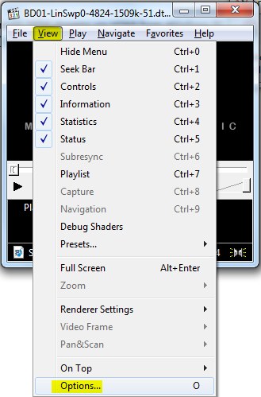

1. Select Internal Filters > Audio Decoder:

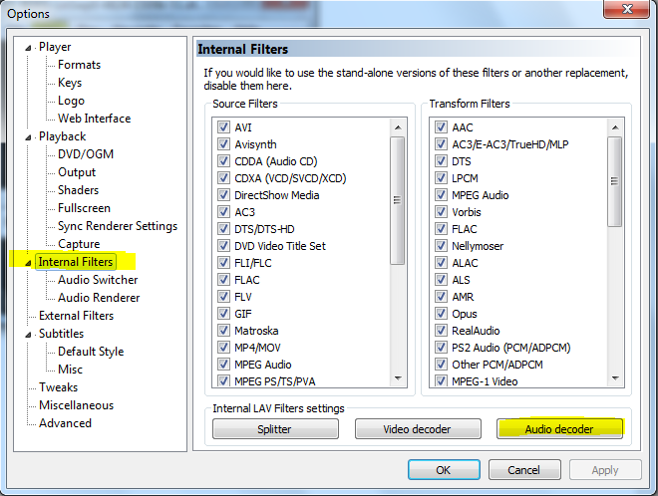

1. Make the setting as shown below:

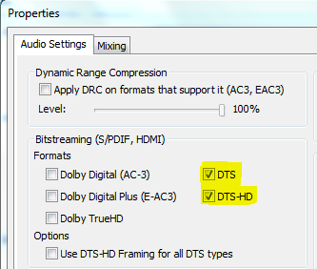

1. Select Audio Renderer, make sure it is System Default:

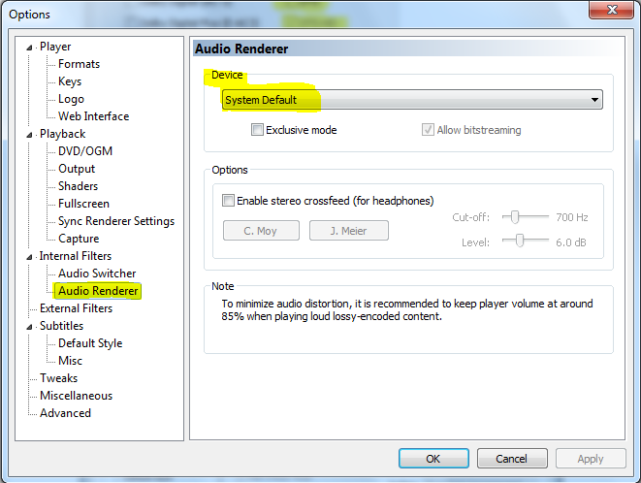

1. Select Output, make sure it is System Default:

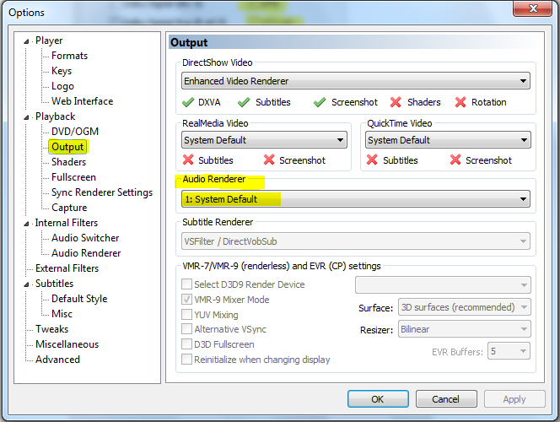

## Integration

DTSX decoder is integrated on K2G ARM core and PARMA is integrated on K2G C66x core.

### DTSX Decoder Integration on K2G ARM Core

1. Get DTSX decoder component libraries from DTSX IP release package:

* dts-3d.lib
* dts-base.lib
* dts-flib.lib
* dts-lbr.lib
* dts-lbr-dec.lib
* dts-parma-dec.lib
* dtsx-c-decoder.lib
* la-strm-reconstruction.lib
* dts-alg.lib

1. Modify patchs.c on ARM to include DTSX decoder into the system.

**#define** _DTS_

**#ifdef** _DTS_

**#include** <dtsuhda.h>

**#include** <dtsuhda_tid.h>

**#endif**

**const** PAF_ASP_LinkInit decLinkInitI13[] =

{

PAF_ASP_LINKINIT(STD, PCM, MDS),

**#ifdef** _DTS_

PAF_ASP_LINKINIT(STD, DTSUHDA, TID),

**#endif**

PAF_ASP_LINKNONE,

};

1. Modify .cmd file to link the DTSX libraries into a build.

For example, copy all the libraries in C:\ti\processor_sdk_audio_1_00_00_06\3p-ip-dts\dtsx-ip\build\a15\release\ folder and add the following lines in .cmd.

SEARCH_DIR ( C:\ti\processor_sdk_audio_1_00_00_06\3p-ip-dts\dtsx-ip\build\a15\release )

INPUT ( dts-3d.lib dts-base.lib dts-flib.lib dts-lbr.lib dts-lbr-dec.lib dts-parma-dec.lib dtsx-c-decoder.lib la-strm-reconstruction.lib dts-alg.lib )

1. Add the path to DTSX header files in CCS Project Directories

For Example:

"${PROC_AUDIO_SDK_ROOT}/3p-ip-dts/dtsx-ip/dec/rel/dtsx/alg"

"${PROC_AUDIO_SDK_ROOT}/3p-ip-dts/dtsx-ip/dec/rel/dtsx/alpha"

### PARMA Integration on K2G C6x Core

1. Get PARMA component libraries from DTSX IP release package.

* dts-3d.lib
* dts-base.lib
* dts-flib.lib
* dts-lbr.lib
* dts-lbr-dec.lib
* dts-parma-dec.lib
* dtsx-c-decoder.lib
* la-strm-reconstruction.lib
* dts-alg.lib

1. Modify patchs.c on DSP to include PARMA into the system.

**#define** _DTS_

**#ifdef** _DTS_

**#include** <dtsuhdb.h>

**#include** <dtsuhdb_mds.h>

**#endif**

**const** PAF_ASP_LinkInit aspLinkInitAllI13[] =

{

**.**

**#ifdef** _DTS_

PAF_ASP_LINKINIT(STD, DTSUHDB, MDS),

**#endif**

PAF_ASP_LINKNONE,

};

1. Modify .cmd file to link the PARMA libraries into a build.

For example, copy all the libraries in C:\ti\processor_sdk_audio_1_00_00_06\3p-ip-dts\dtsx-ip\build\c66x\release\ folder and add the following lines in .cmd.

-i"C:\ti\processor_sdk_audio_1_00_00_06\3p-ip-dts\dtsx-ip\build\c66x\release"

-**l**"dts-3d.lib"

-**l**"dts-base.lib"

-**l**"dts-flib.lib"

-**l**"dts-lbr.lib"

-**l**"dts-lbr-dec.lib"

-**l**"dts-parma-dec.lib"

-**l**"dtsx-c-decoder.lib"

-**l**"la-strm-reconstruction.lib"

-**l**"dts-alg.lib"

1. Add the path to PARMA header files in CCS Project Directories

For Example:

"${PROC_AUDIO_SDK_ROOT}/3p-ip-dts/dtsx-ip/asp/rel/parma/alg"

"${PROC_AUDIO_SDK_ROOT}/3p-ip-dts/dtsx-ip/asp/rel/parma/alpha"

"${PROC_AUDIO_SDK_ROOT}/3p-ip-dts/dtsx-ip/dec/rel/dtsx/alg"

"${PROC_AUDIO_SDK_ROOT}/3p-ip-dts/dtsx-ip/dec/rel/dtsx/alpha"